**COPY THE FILES FROM SERVER –1 TO SERVER -2 BY USING SHELL SCRIPT**

**STEP:1: -**

**Creating the Instances:**

First, we create the two instances in AWS Console in EC2 Dashboard and open the two instances with ssh tool.

**SERVER-1:**

*Creating a Script file and write the script in the file in Server-1:*

sudo vi one.sh

#!/bin/bash

# Creating the files by using touch command

touch test.txt test.py test

# Creating a ssh key

ssh-keygen

# Copying the ssh key to another Server

ssh-copy-id ec2-user@13.233.83.237

# Transferring the files from this server to another server

scp -r test.txt test.py test ec2-user@13.233.83.237:/home/ec2-user

🡺 save the file.

**STEP:2: -**

*Run the script:*

sudo sh one.sh

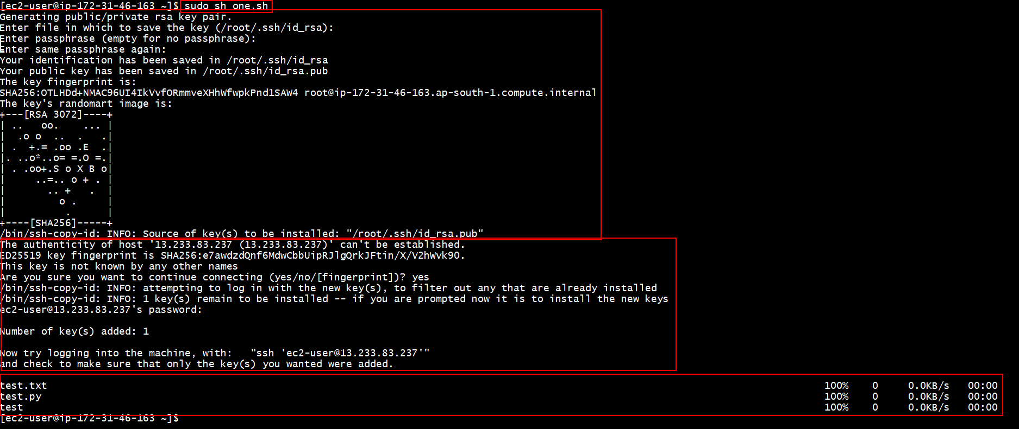

In the image the first highlight was running the script command

Second highlight is creating the ssh key file

Third highlight was copying the ssh key to Server-2

Fourth highlight was transferred the files from server-1 to Server-2 by the command of **scp.**

**STEP:3: -**

**SERVER-2:**

*Checking the files transferred or not*

*The transferred files as shown below in Server-2:*

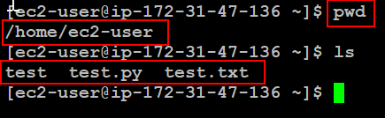

First highlight was checking the path where we are now and showing in the second highlight was current directory

Third highlight was the files transferred from Server-1 to Server-2 by the command of **scp**.